NAME: Donald McLaughlin

ASSIGNMENT: PROJECT 2

DIAGRAM:

**Image on next page below**

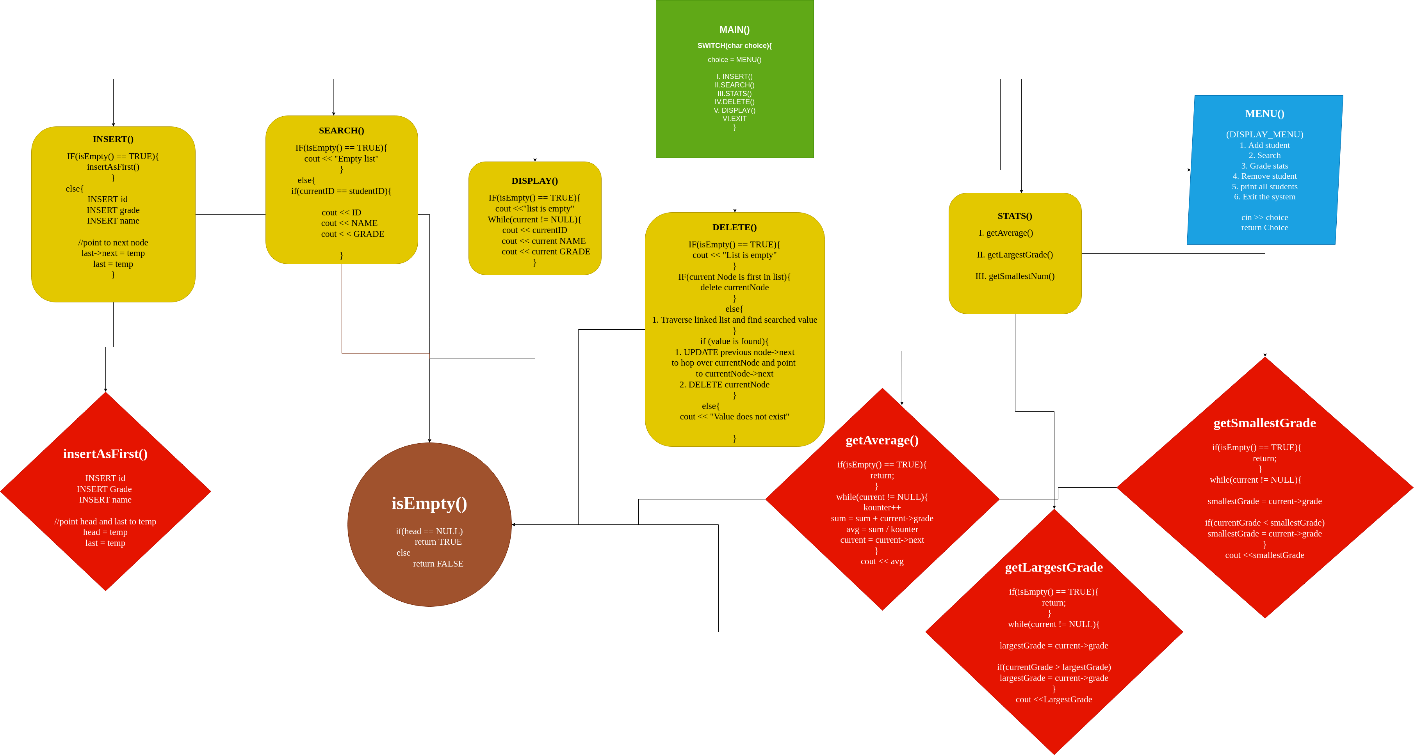
STEPS IN PROGRAM:

0. DISPLAY MENU()

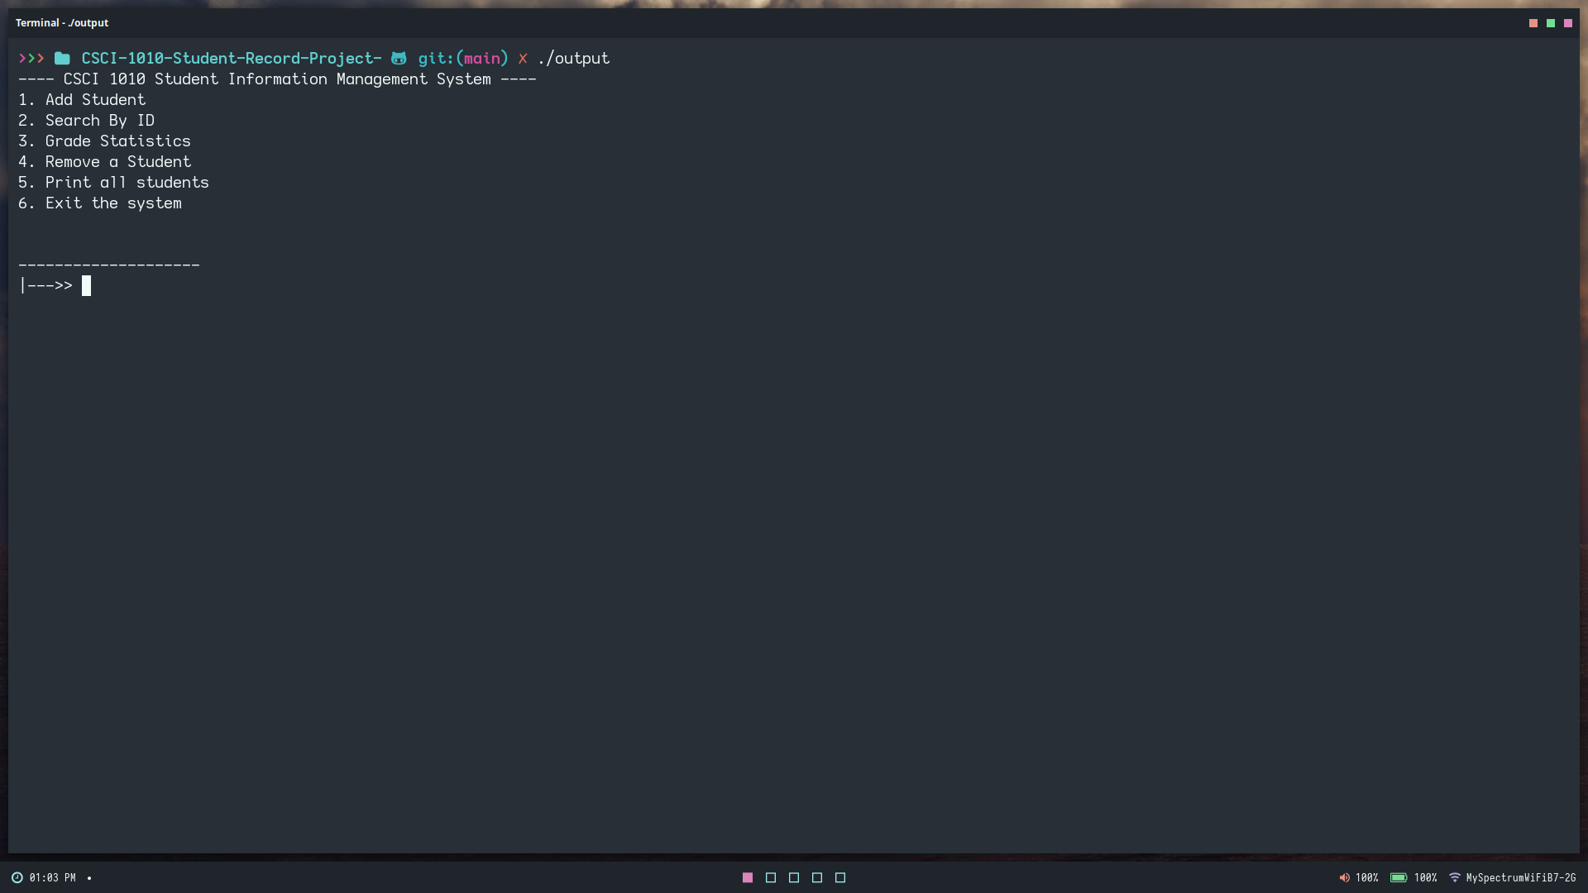

1. ADD STUDENT()

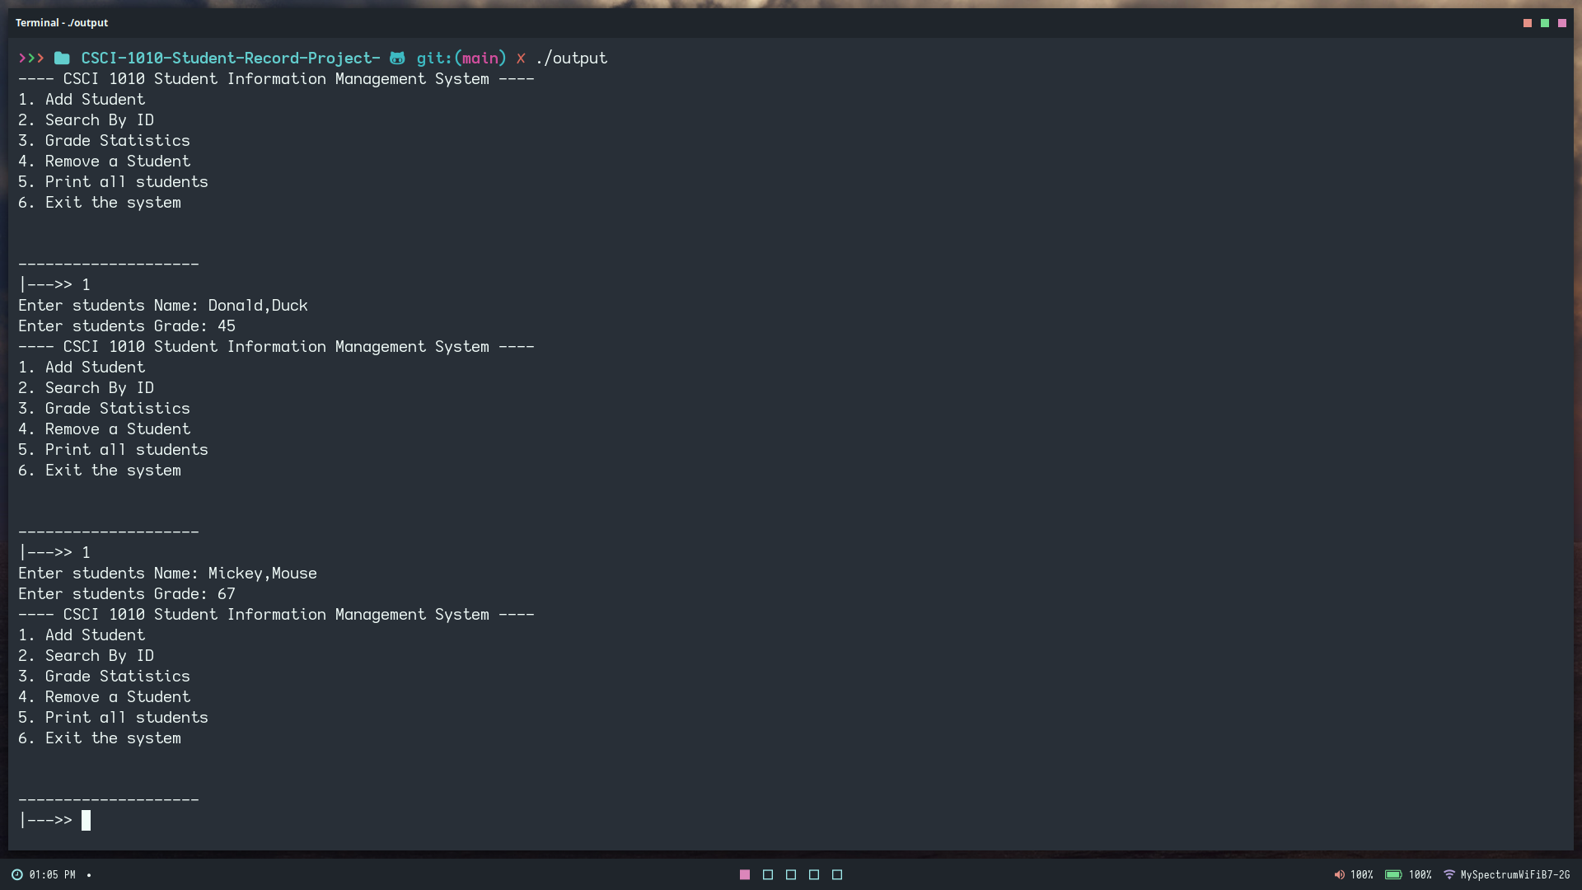

2. SEARCH()

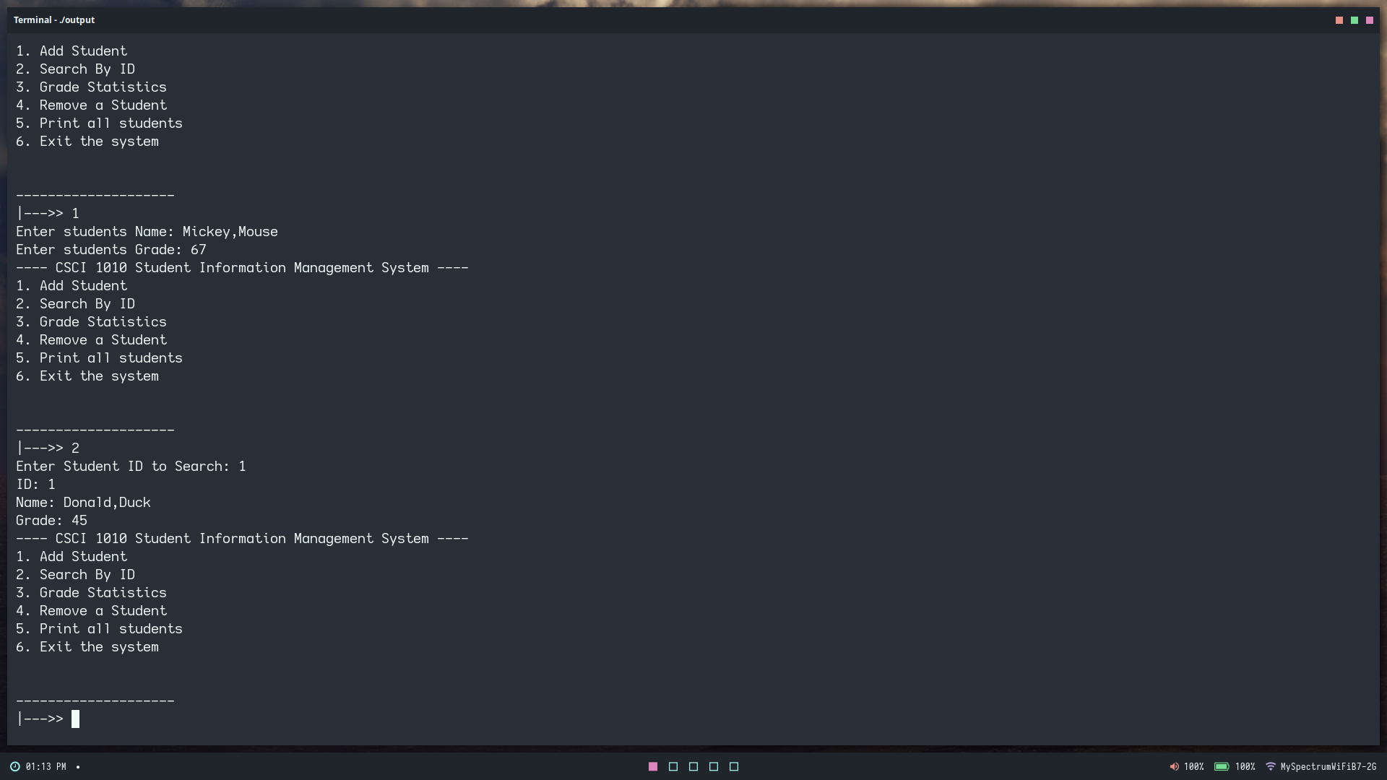

3. STATS()

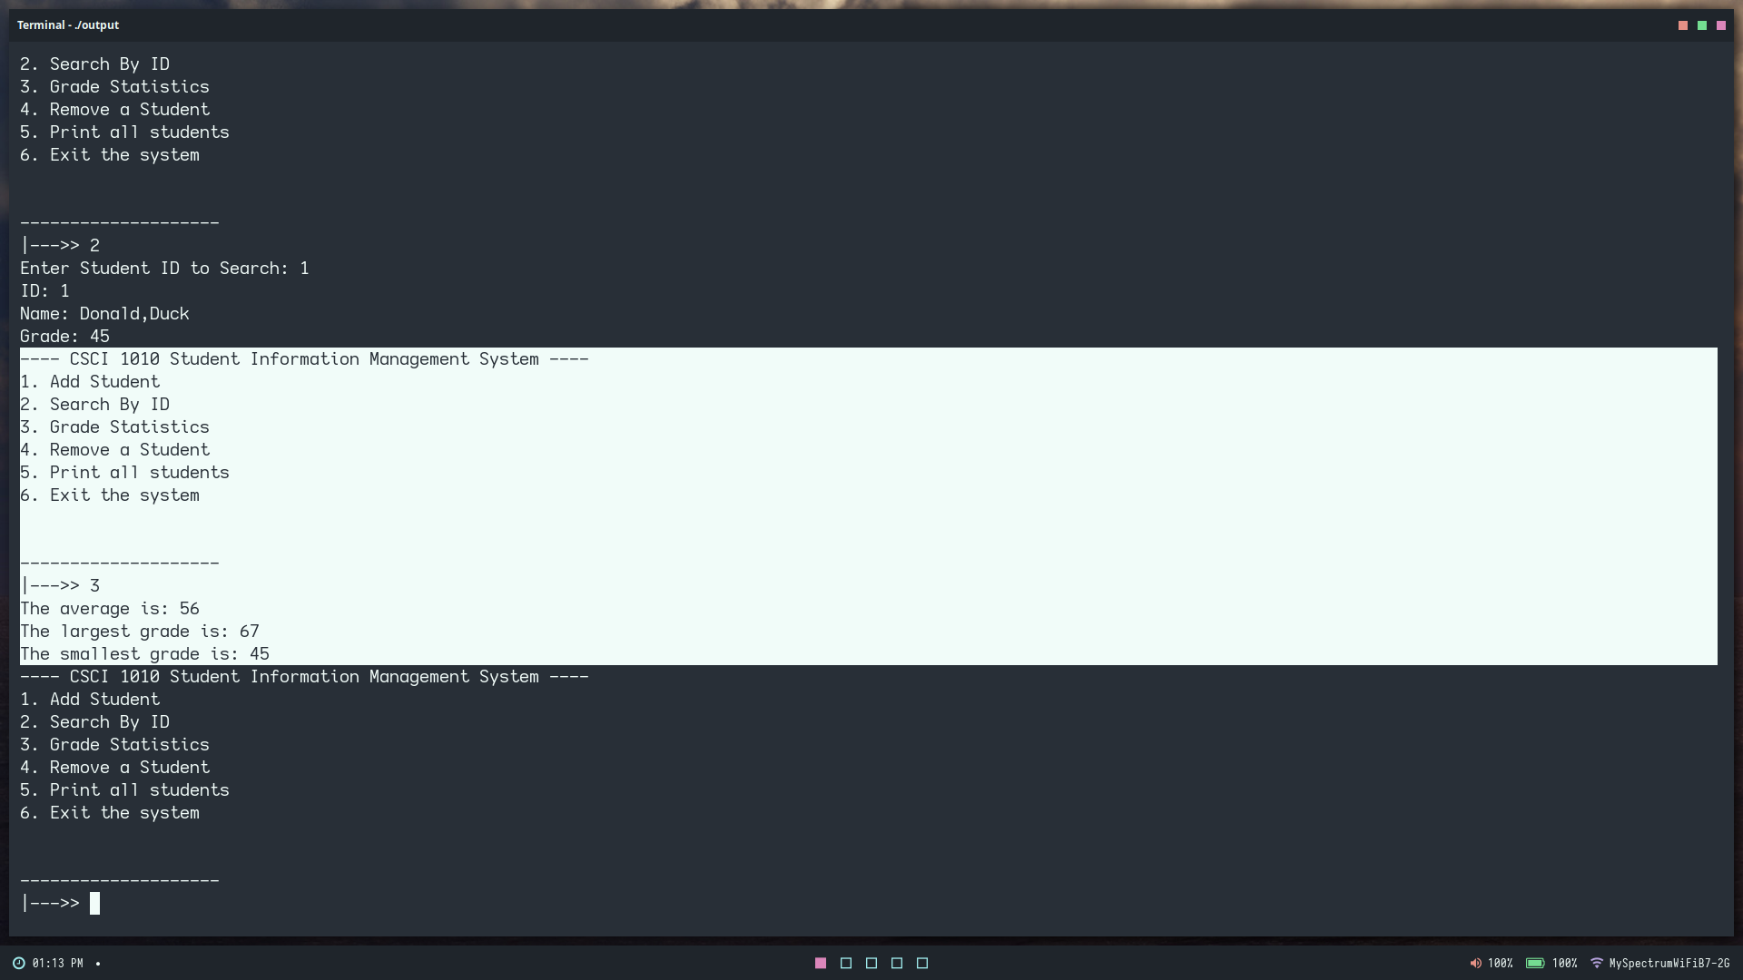

4. DELETE()

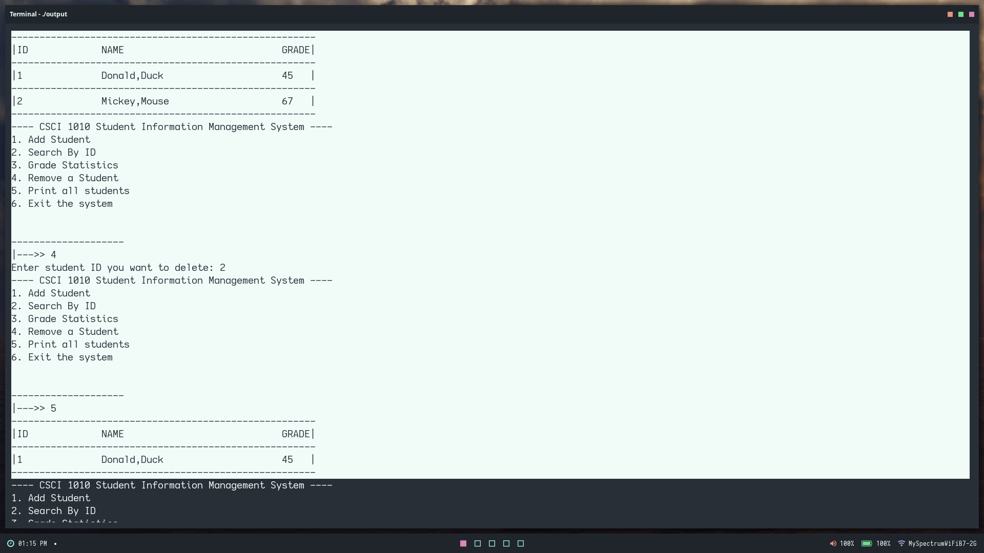

5. PRINTALL()

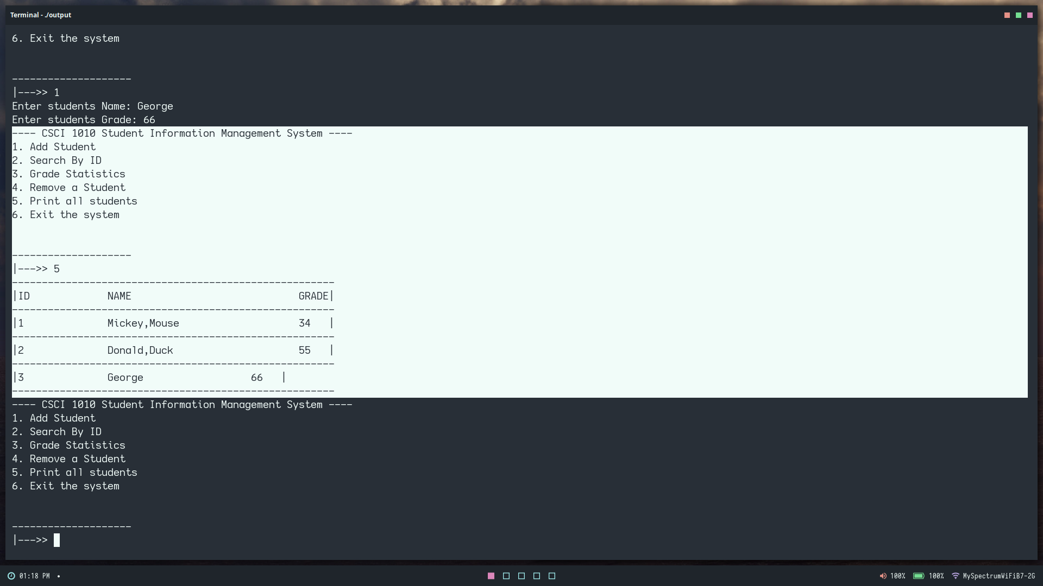

6. EXIT

